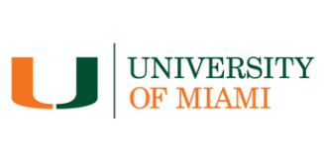
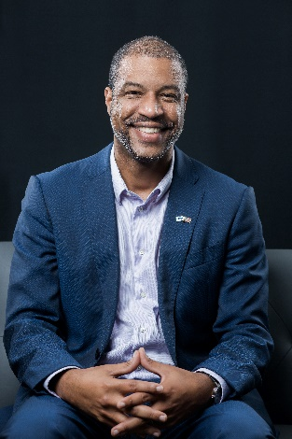
David Mullings
Founder and Chair
Blue Mahoe Holdings

David Mullings is the founder and chair of Blue Mahoe Holdings, a Miami-based impact investment firm focused primarily on the Caribbean, and is listing their core company, Blue Mahoe Capital, on the NASDAQ in 2025. Mullings is a vice president of the Alumni Board of Directors and graduated with his Bachelor of Science degree from the University of Miami at the young age of 19. He then played football (soccer) with Real Mona F.C. in Jamaica, returning to graduate school and completing his M.B.A. at the University of Miami Patti and Allan Herbert Business School at the age of 22, with concentrations in marketing and international business. His brother, Robert, also graduated from the U with a bachelor’s degree at 19 and an M.B.A. at 21. Their father, Dr. Anthony Mullings, graduated from the U with a master’s in public health. David and Robert launched their first startup through The Launch Pad at UM in 2002. The Mullings Family Foundation has committed to endowing a scholarship at the Miami Herbert Business School for students focused on Caribbean economic development beginning in fall 2025.

Mullings has positioned himself and his companies to be a catalyst that can revolutionize business, not just in the United States, but also in Jamaica, the Caribbean, and throughout the African diaspora. Along with innovative business practices and approaches, he prioritizes educating people on how triple bottom line investing works to generate profits while benefiting people and being planet-positive.

Mullings serves on numerous boards of organizations and companies in the United States and Jamaica.

He was the first Future Leaders Representative for the U.S. on the Jamaica Diaspora Advisory Board, which advises Jamaca’s Prime Minister and Minister of Foreign Affairs, and he was a weekly columnist for the Jamaica Observer newspaper. He began his finance career at Jamaica National Building Society and held three positions at different periods, most notably on the Marketing and Business Development team, where he helped to design investment, mortgage, and savings products and oversaw electronic channels for the entire group, launching their internet banking platform, JN Live. He also worked for Left Brain Capital Management, a Chicago-based long-biased hedge fund, before launching Blue Mahoe.

Mullings was born in Jamaica and raised between Kingston and Miami. He has been married to Kathryn for 17 years and has three children.

